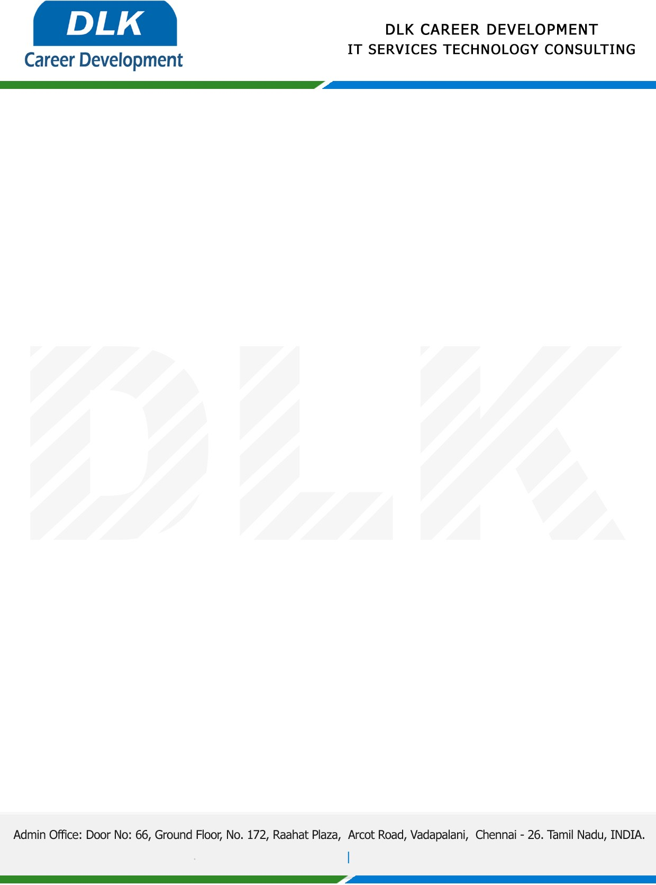

**Date: 04/ May / 2023**

**SUB: PROJECT COMPLETION CERTIFICATE**

This is to certify that **MR SANTHOSH S (REG NO:** **311519104051)** **BE- Computer Science and Engineering**, final year student at **Meenakshi Sundararajan Engineering College, Chennai** has Successfully Completed the Project work under the domain “**Python**” in our organization during the Period **(1st February 2023 to 30th April 2023).**

**Topic:** Automated Resume Recommendation System

**“Best Wishes for Your Future Endeavors “**

For **DLK CAREER DEVELOPMENT**

**HR Manager**

**VELMURUGAN J**